AGO Data Challenge

BNO Analytics

Team Members: Benjamin Ng, Nicholas Chung, Owen Tan

# Anomaly Finding

## Checking the Validity of Dates

There is 1 row, SN 1 that had its procurement date before 2017.

|  |  |  |  |  |  |  |  |
| --- | --- | --- | --- | --- | --- | --- | --- |
| SN | Code | Type | Agency | Description | Date | Supplier | Amount |
| 1 | ITQ20160157 | ITQ | National Institute of Scientific Advancement | Parking management and traffic control solutions. | 2016-07-01 | SafeHaven Maintenance | 40532 |

There are 2 rows, SN6999 and SN7000 that have their procurement dates in 2023 and 2024 respectively.

|  |  |  |  |  |  |  |  |
| --- | --- | --- | --- | --- | --- | --- | --- |
| SN | Code | Type | Agency | Description | Date | Supplier | Amount |
| 6999 | ITT20230691 | ITT | National Institute of Scientific Advancement | Fire safety system installation and maintenance. | 2023-08-15 | CleanSweep Property Management | 295089 |
| 7000 | ITT20240605 | ITT | Commission for Ethical Governance | Energy-efficient systems and consumption monitoring. | 2024-08-29 | TrueWave Facilities Management | 316264 |

The three data points should not be considered as the dataset covers awards between 1 January 2017 and 31 December 2022.

## Checking the Amount Awarded for ITT and ITQ

There are 10 projects listed in ITQ that fall below $10,000 in amount awarded.

|  |  |  |  |  |  |
| --- | --- | --- | --- | --- | --- |
| SN | Code | Agency | Description | Supplier | Amount |
| 117 | ITQ20170116 | Bureau of National Security and Intelligence | Indoor air quality monitoring and improvement measures. | SafeHarbor Facilities Group | 9509 |
| 262 | ITQ20170261 | Department of Advanced Technological Research | Pest control services for a pest-free environment. | StarStone Facility Services | 9072 |
| 396 | ITQ20180087 | Bureau of National Security and Intelligence | Parking management and traffic control solutions. | GoldenGate Facility Masters | 9888 |
| 629 | ITQ20190014 | Department of Advanced Technological Research | Energy-efficient lighting installation and maintenance. | UrbanTech Management | 9998 |
| 644 | ITQ20190029 | Bureau of National Security and Intelligence | Renovation and remodeling project management. | EverGreen Property Support | 9438 |
| 807 | ITQ20190192 | Bureau of National Security and Intelligence | Space planning and utilization optimization strategies. | SafeReach Property Solutions | 9854 |
| 1099 | ITQ20200144 | Department of Advanced Technological Research | Furniture and equipment maintenance and inventory tracking. | BlueSky Property Care | 9161 |
| 1195 | ITQ20210029 | Bureau of National Security and Intelligence | Tenant communication and customer service assistance. | BlueReach Property Solutions | 9537 |
| 1316 | ITQ20210150 | Department of Advanced Technological Research | HVAC system maintenance and climate control optimization. | InfiniteGuard Building Care | 9407 |
| 1392 | ITQ20220013 | Department of Advanced Technological Research | Emergency response and disaster recovery planning. | SecureReach Property Care | 8069 |

While it is odd that projects below $10,000 are going through ITQ instead of SVP, ITQ does not have a minimum threshold unlike ITT, hence we will keep these data points for our analysis.

# Analysis

There are 15 different agencies, 20 different procurement description types, and 98 different suppliers, spread across 6997 different projects.

The following are the top 5 and bottom 5 agencies in terms of number of projects.

**Agency Number of Projects**  
Institute for Social Justice and Equality 1050  
Commission for Ethical Governance 916  
Agency for Cultural Preservation and Heritage 586  
Office of International Relations and Diplomatic Affairs 568  
National Commission for Space Exploration 555

National Cybersecurity Task Force 326  
Bureau of National Security and Intelligence 277  
Office of Public Safety and Emergency Management 200  
Bureau of Urban Development and Infrastructure 139  
Department of Public Health and Disease Control 115

The following are the top 5 and bottom 5 suppliers in terms of number of projects.

**Supplier Number of Projects**  
InfiniteSpace Building Solutions 238  
InfiniteGuard Building Care 225  
SecureSpace Management 177  
ApexGuard Facility Services 163  
GreenWave Facilities Management 135

HighWave Building Solutions 43  
CleanHarbour Facility Care 42  
SecureTech Building Solutions 42  
StarTech Facility Solutions 42  
SwiftTech Facility Solutions 17

|  |  |
| --- | --- |
|  | |
|  |  |
|  |  |
|  |  |
|  |  |
|  |  |

We also observe that the median amount awarded is $240,989, and the mean is $250,870. It is also interesting that the maximum amount awarded is very much higher than the 3rd quartile, at over $3.7 million.

## Min. 1st Qu. Median Mean 3rd Qu. Max.   
## 8069 120509 **240989**  250870 365022 **3773118**

There are 5 projects that go above $1 million in amount awarded. These are overly represented by the Bureau of Urban Development and Infrastructure as the procurement agency, at 4 out of the 5 projects.

|  |  |  |  |  |
| --- | --- | --- | --- | --- |
| SN | Agency | Description | Date | Amount |
| 2198 | Bureau of Urban Development and Infrastructure | Building maintenance and repairs. | 2017-08-08 | 2646865 |
| 3492 | National Institute of Scientific Advancement | Indoor air quality monitoring and improvement measures. | 2018-08-27 | 1284388 |
| 5087 | Bureau of Urban Development and Infrastructure | Space planning and utilization optimization strategies. | 2020-02-14 | 3773118 |
| 6472 | Bureau of Urban Development and Infrastructure | Health and safety compliance management and training. | 2021-09-19 | 1415452 |
| 6619 | Bureau of Urban Development and Infrastructure | Parking management and traffic control solutions. | 2021-11-23 | 2337266 |

Looking further into the Bureau of Urban Development and Infrastructure (BUDI), we find that they have 139 different procurements. The median procurement amount of procurements awarded by BUDI is $226,170, which is actually lower than the overall median procurement amount.

Min. 1st Qu. Median Mean 3rd Qu. Max.   
 11797 86768 **226170** 294975 346104 3773118

## Correlation between Agency and Description

We first try to find the needs of the agencies in terms of procurement description categories.

On average, one procurement description category takes approximately 5% of an agency’s total procurement needs. This translates to about 20 different procurement description categories undetaken by one agency, meaning most agencies require a wide variety of procurements. It is also interesting to note that the maximum percentage recorded is 13.7%. This means that there are no agencies with an overwhelming focus on one particular procurement description category.

Min. 1st Qu. Median Mean 3rd Qu. Max.   
 0.8696 3.8285 **4.5852** 5.0167 5.4435 **13.7184**

The dotplot below also corroborates our above findings.

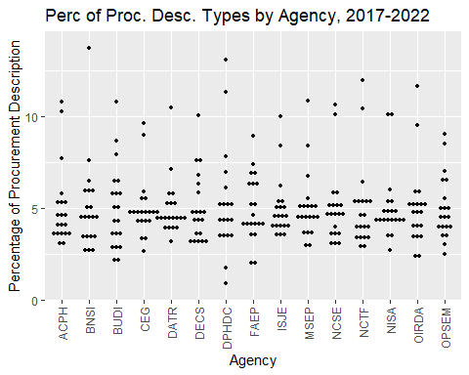

# Correlation between Supplier and Description

Now we look at the different suppliers and what type of services they provide (based on the procurement description).

Min. 1st Qu. Median Mean 3rd Qu. Max.   
 0.4202 3.2609 **4.9180** 5.5493 7.0423 **79.8319**

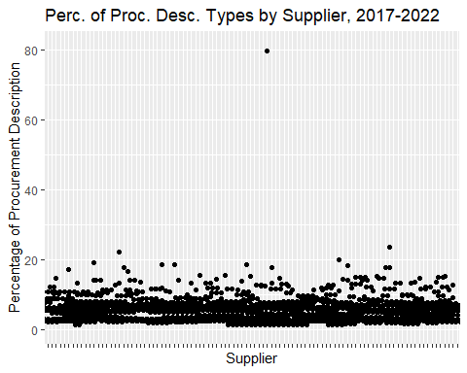

The data and boxplot above shows that most suppliers are diverse in the services they provide, as one category of procurement description accounts for about 5% of the total number of projects done by the supplier. Although there are some values that cross 20%, of particular interest to us in the data point hovering at about 80%.

|  |  |  |  |  |
| --- | --- | --- | --- | --- |
| SN | Supplier | Description | Frequency | Percentage |
| 941 | InfiniteSpace Building Solutions | Cleaning supplies and consumables procurement and management. | 190 | 79.83193 |

The data point in question belongs to InfiniteSpace Building Solutions. We want to look at the share of other projects that this supplier takes on. We look at the top 3 and bottom 3 procurement description categories done by this supplier.

|  |  |  |  |  |
| --- | --- | --- | --- | --- |
| SN | Supplier | Description | Frequency | Percentage |
| 1 | InfiniteSpace Building Solutions | Cleaning supplies and consumables procurement and management. | 190 | 79.83193 |
| 2 | InfiniteSpace Building Solutions | Building automation and smart technology integration. | 5 | 2.1008403 |
| 3 | InfiniteSpace Building Solutions | Building maintenance and repairs. | 5 | 2.1008403 |
| 17 | InfiniteSpace Building Solutions | Expert landscaping and groundskeeping solutions. | 1 | 0.4201681 |
| 18 | InfiniteSpace Building Solutions | Parking management and traffic control solutions. | 1 | 0.4201681 |
| 19 | InfiniteSpace Building Solutions | Space planning and utilization optimization strategies. | 1 | 0.4201681 |

We observe that there are 19 different procurement description types that the supplier takes on, but the other 18 types take between 0.4%-2.1% share of the projects done by said supplier. This means that the supplier can perform a lot of different projects, but only “Cleaning supplies and consumables procurement and management” is heavily preferred by agencies for this supplier.

# Correlation Between Agency and Supplier

Finally, we also want to analyse if there are agencies that are particularly reliant on a particular supplier for their needs.

## Min. 1st Qu. Median Mean 3rd Qu. Max.   
## 0.1706 0.6135 **0.9203** 1.1119 1.4286 **31.8919**

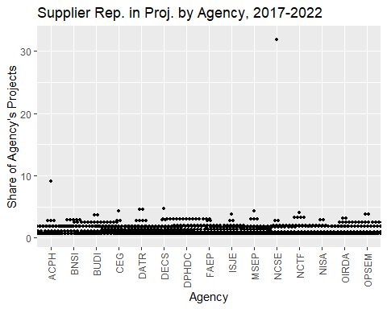

From the data above, it is apparent that most agencies do not over rely on one particular supplier, as one supplier only takes a share of about 1% of an agency’s total procurements.

However, there is one data point that is above 30%, which we shall further scrutinise.

|  |  |  |  |  |
| --- | --- | --- | --- | --- |
| SN | Agency | Supplier | Frequency | Percentage |
| 959 | National Commission for Space Exploration | SecureSpace Management | 177 | 31.89189 |

The data point in question belongs to the National Commission for Space Exploration, and the supplier in question is SecureSpace Management.

We shall now look into how many different suppliers the National Commission for Space Exploration engages to check for any overreliance on their suppliers.

|  |  |  |  |  |
| --- | --- | --- | --- | --- |
| SN | Supplier | Supplier | Frequency | Percentage |
| 1 | National Commission for Space Exploration | SecureSpace Management | 177 | 31.8918919 |
| 2 | National Commission for Space Exploration | InfiniteGuard Building Care | 15 | 2.7027027 |
| 3 | National Commission for Space Exploration | InfiniteSpace Building Solutions | 15 | 2.7027027 |
| 89 | National Commission for Space Exploration | SecureTech Building Solutions | 1 | 0.1801802 |
| 90 | National Commission for Space Exploration | StarTech Facility Solutions | 1 | 0.1801802 |
| 91 | National Commission for Space Exploration | SwiftGuard Management | 1 | 0.1801802 |

We observe that there are 91 different suppliers that the agency engages, but the other 90 suppliers take between 0.1%-2.7% share of the procurements by the agency. This means that the agency does engage a wide range of suppliers, but SecureSpace Management in particular takes a significantly larger share of their procurements. We observe that there are 91 different suppliers that the agency engages, but the other 90 suppliers take between 0.1%-2.7% share of the procurements by the agency. This suggests that the agency does engage a wide range of suppliers, but SecureSpace Management in particular takes a significantly larger share of their procurements.

**Description Freq**  
 Energy-efficient lighting installation and maintenance. 20  
 Emergency response and disaster recovery planning. 14  
 Pest control services for a pest-free environment. 13  
 Building maintenance and repairs. 11  
 24/7 security and access control management. 10  
 Energy-efficient systems and consumption monitoring. 10  
 Fire safety system installation and maintenance. 10  
 Furniture and equipment maintenance and inventory tracking. 10  
 Indoor air quality monitoring and improvement measures. 9  
 Renovation and remodeling project management. 9  
 Expert landscaping and groundskeeping solutions. 8  
 HVAC system maintenance and climate control optimization. 8  
 Space planning and utilization optimization strategies. 8  
 Tenant communication and customer service assistance. 8  
 Health and safety compliance management and training. 7  
 Parking management and traffic control solutions. 7  
 Waste management and recycling program implementation. 7  
 Building automation and smart technology integration. 4  
 Comprehensive janitorial services and cleanliness maintenance. 4

The above table shows the type of projects done by SecureSpace Management and are procured by the National Commission for Space Exploration (NCSE). These are spread across 19 different procurement description categories, which means that NCSE is significantly more reliant on SecureSpace Management for a large number of their different needs.

# Recommendations

1. The 10 ITQ procurements below $10,000 can be procured through SVP instead of ITQ to minimise paperwork and increase efficiency.
2. The Bureau of Urban Development and Infrastructure (BUDI) is overrepresented in ITT procurements above $1 million. BUDI should consider ‘spreading out’ its procurements across different procurement instances to enhance competition and ensure greater business continuity in the event that one supplier is unable to fulfil the procurement request.
3. The supplier, InfiniteSpace Building Solutions, is particularly concentrated on the procurement category “cleaning supplies and consumables procurement and management”. Since InfiniteSpace Building Solutions also offers almost all the other procurement categories, agencies could consider procuring more of other procurement categories from InfiniteSpace Building Solutions.
4. The agency, National Commission for Space Exploration (NCSE), is overly reliant on the supplier, SecureSpace Management for a wide variety of procurement categories. As NCSE already has procurements from many different suppliers, it should diversify its procurements away from NCSE and strive for a more equal share of projects awarded to its suppliers, which would help in the event SecureSpace Management is unable to fulfil its procurement requests.